Jon Rippe  
CSCE A415  
HW #1.1

## Problem 1: Decision Trees

|  |  |  |  |
| --- | --- | --- | --- |
| Size | Orbit | Habitable | Count |
| big | near | yes | 20 |
| big | far | yes | 170 |
| small | near | yes | 139 |
| small | far | yes | 45 |
| big | near | no | 130 |
| big | far | no | 30 |
| small | near | no | 11 |
| small | far | no | 255 |

### Determine Overall Entropy:

$$E=H\left(S\right)=-p_{+}\log_{2}{p_{+}}-p_{-}\log_{2}{p_{-}}$$

Overall:

$\#S=20+170+139+45+130+30+11+255=800$

$P\left(\text{yes}\right)=p_{+}=\frac{20+170+139+45}{800}=\frac{374}{800}=.4675$

$P\left(\text{no}\right)=p_{-}=1-.4675=.5325$

$E\left(\text{overall}\right)=-.4675\log_{2}{(.4675)}-.5325\log_{2}{(.5325)}=.9970$

### Find the best Gain:

Size:

* Big
$\#S=20+170+130+30=350$

$p_{+}=\frac{20+170}{350}=\frac{190}{350}=.5429$

$p_{-}=1-.5429=.4571$

$E\left(\text{big}\right)=-.5429\log_{2}\left(.5429\right)-.4571\log_{2}\left(.4571\right)=.9947$

* Small

$\#S=139+45+11+255=450$

$p_{+}=\frac{139+45}{450}=\frac{184}{450}=.4089$

$p_{-}=1-.4089=.5911$

$E\left(\text{small}\right)=-.4089\log_{2}\left(.4089\right)-.5911\log_{2}\left(.5911\right)=.9759$

$Gain\left(\text{size}\right)=.9970-\left(\frac{350}{800}\right).9947-\left(\frac{450}{800}\right).9759=.0129$

Orbit:

* Near
$\#S=20+139+130+11=300$

$p_{+}=\frac{20+139}{300}=\frac{159}{300}=.5300$

$p_{-}=1-.5300=.4700$

$E\left(\text{near}\right)=-.5300\log_{2}\left(.5300\right)-.4700\log_{2}\left(.4700\right)=.9974$

* Far

$\#S=170+45+30+255=500$

$p_{+}=\frac{170+45}{500}=\frac{215}{500}=.4300$

$p_{-}=1-.5700=.5700$

$E\left(\text{far}\right)=-.4300\log_{2}\left(.4300\right)-.5700\log_{2}\left(.5700\right)=.9858$

$Gain\left(\text{orbit}\right)=.9970-\left(\frac{300}{800}\right).9974-\left(\frac{500}{800}\right).9858=.0069$

### Start the Decision Tree:

There are only two attributes, *size* and *orbit*. The tree will start with *size* because it shows the most gain in the calculations.

### Calculate Orbit Probabilities

Calculating the probability of Y given both attributes for all combinations will give the final Yes/No leaves.

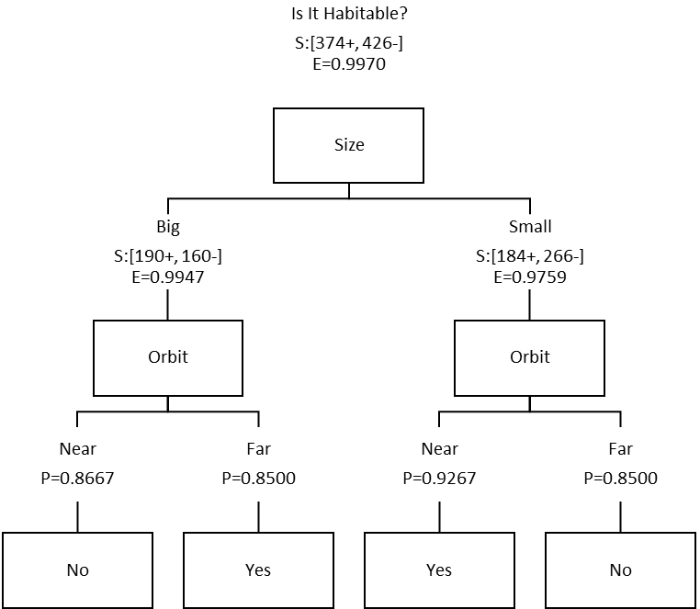

*Wherever you are!*

$$P\left(Y | \text{big}\text{ ⋀ near}\right)=\frac{20}{150}=.1333 \\ P\left(\overline{Y} | \text{big}\text{ ⋀ near}\right)=1-.1333=.8667 \\ P\left(Y | \text{big}\text{ ⋀ }\text{far}\right)=\frac{170}{200}=.8500 \\ P\left(\overline{Y} | \text{big}\text{ ⋀ }\text{far}\right)=1-.8500=.1500 \\ P\left(Y | \text{small}\text{ ⋀ near}\right)=\frac{139}{150}=.9267 \\ P\left(\overline{Y} | \text{small}\text{ ⋀ near}\right)=1-.9267=.0733 \\ P\left(Y | \text{small}\text{ ⋀ }\text{far}\right)=\frac{45}{300}=.1500 \\ P\left(\overline{Y} | \text{small}\text{ ⋀ }\text{far}\right)=1-.1500=.8500$$